

4.8: If-Else Statements

# 4.8: If-Else Statements

Whilst this function works correctly, there is an issue which means that if a number is entered which is not even (i.e. odd), we get an output which is not particularly helpful:

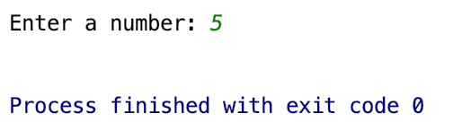

The program runs and finished successfully (hence the exit code of 0), but the output of a blank line doesn’t tell us anything – and makes it look like the program didn’t work when it did. To overcome this, we want to have a line which says “5 is odd” when the if statement is not satisfied. This is where our else statement comes in. Adapt your code so that it says the following:

if(int(number) % 2 == 0):

print(number + " is even")

else:

print(number + " is odd")

You should now get the following result:

 for an even number

for an odd number

**Your Turn 2:**

Adapt your program payday program so that when the user doesn’t enter Friday it now says:

“Not Payday :(”

It should still say “Payday!” when the user enters Friday

*(Note: for this program, we are assuming that the person gets paid each week on a Friday)*